WEEKLY TASK 2
AUTOMATION TOOL

Full Name: Asma Noonari
Internship Domain: Python Developer
Email Address: asmanoonari18@gmail.com
Task: Automation Tool
DATA PROCESSER

1. Introduction
Automation allows computers to perform repetitive tasks with little manual effort. In this project, a Python tool automatically processes sales data stored in a CSV file and generates a summary report.

2. Objective
The objective is to build a useful Python automation tool that reads CSV data, calculates total and category-wise sales, and creates an output report automatically.

3. Tools and Technologies
Python 3, CSV module, file handling, functions, loops, dictionaries, and VS Code or another Python IDE.

4. How the Automation Works
The program opens the input CSV file, reads each record, converts the Amount field into a number, calculates total sales and category totals, and writes the results into a new CSV report. A completion message is then displayed.

5. Features
• Automatic CSV reading
• Processing of multiple records
• Total sales calculation
• Category-wise sales summary
• Automatic report generation
• Function-based reusable design

6. Code Implementation
The complete Python implementation is provided below.
import csv

INPUT_FILE = "sales_data.csv"
OUTPUT_FILE = "sales_report.csv"

def process_csv(input_file, output_file):
total_sales = 0
total_records = 0
category_totals = {}

with open(input_file, "r", newline="", encoding="utf-8") as file:
reader = csv.DictReader(file)

for row in reader:
amount = float(row["Amount"])
category = row["Category"]

total_sales += amount
total_records += 1
category_totals[category] = category_totals.get(category, 0) + amount

with open(output_file, "w", newline="", encoding="utf-8") as file:
writer = csv.writer(file)
writer.writerow(["Metric", "Value"])
writer.writerow(["Total Records", total_records])
writer.writerow(["Total Sales", f"{total_sales:.2f}"])

for category, total in category_totals.items():
writer.writerow([f"Sales - {category}", f"{total:.2f}"])

print("Automation completed successfully!")
print(f"Processed records: {total_records}")
print(f"Total sales: {total_sales:.2f}")
print(f"Report saved to: {output_file}")

if __name__ == "__main__":
process_csv(INPUT_FILE, OUTPUT_FILE)

7. Sample Input CSV
Date,Product,Category,Amount
2026-09-01,Laptop,Electronics,85000
2026-09-02,Mouse,Accessories,2500
2026-09-03,Keyboard,Accessories,4500
2026-09-04,Monitor,Electronics,30000
2026-09-05,Headphones,Accessories,6000

8. Exam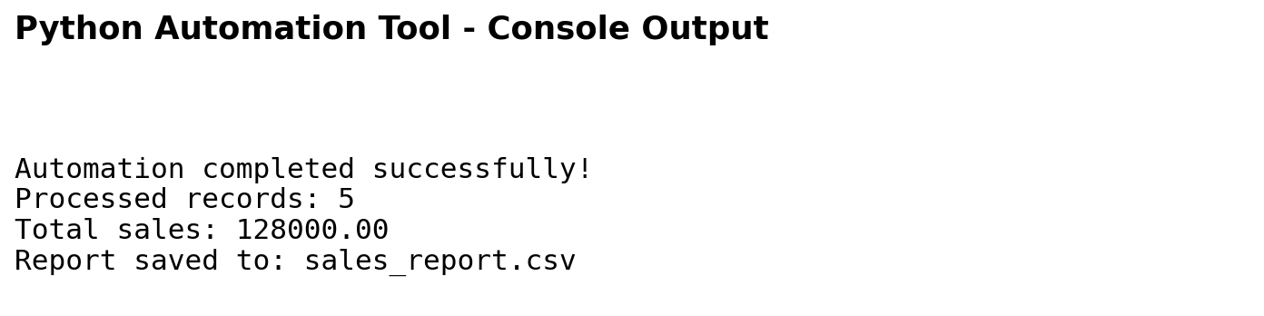

9. Learning Outcomes
- Understanding how Python can automate repetitive work.
- Reading and writing CSV files.
- Using functions, loops, dictionaries, and file handling.
- Generating a report automatically.
- Applying Python to a practical data-processing problem.

10. Possible Improvements
The tool could be improved with error handling, Excel output, charts, date filters, automatic folder scanning, email delivery, and a graphical user interface.

11. Conclusion
This project shows how Python can convert a repetitive CSV-processing task into an automated workflow. The program performs calculations consistently and generates a useful report without manual processing.

